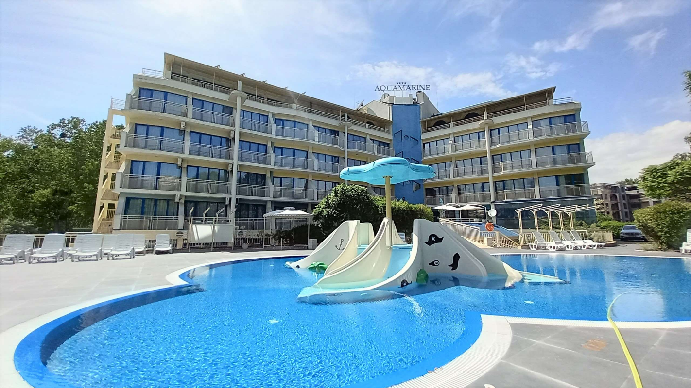
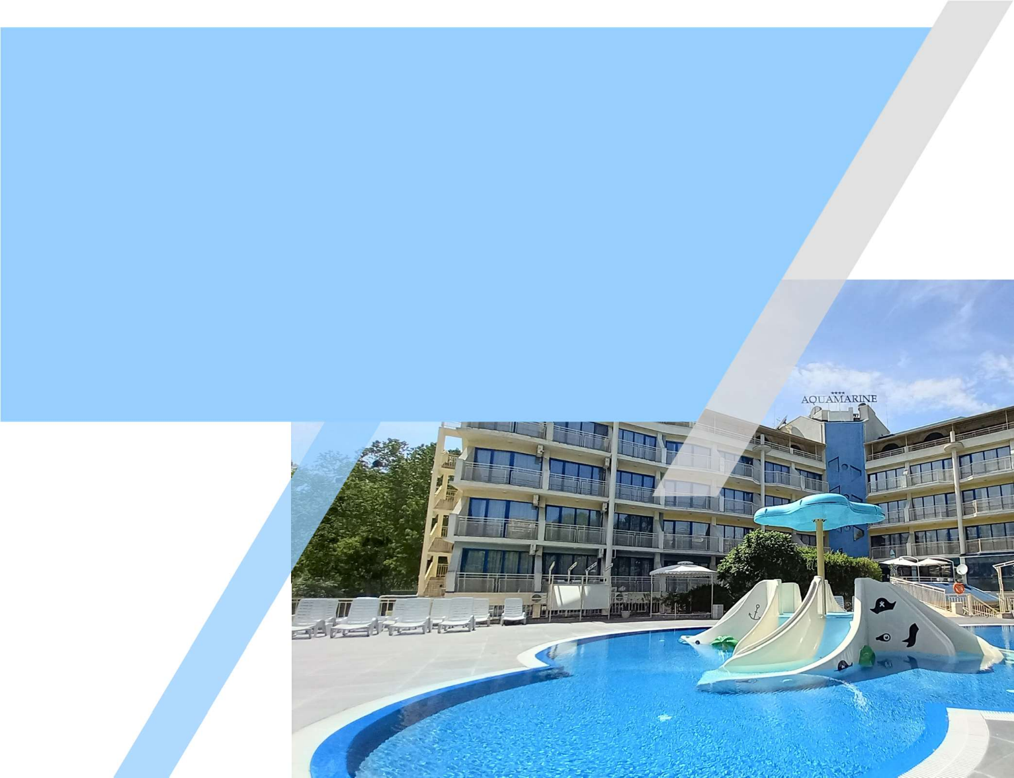
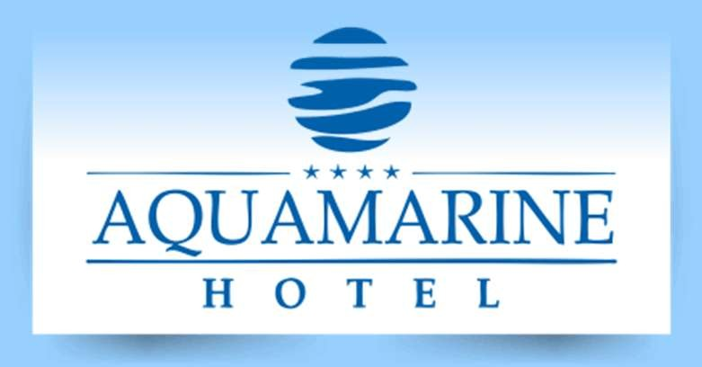
Hotel Aquamarine, Sunny Beach

Website: www.aquamarine.bg

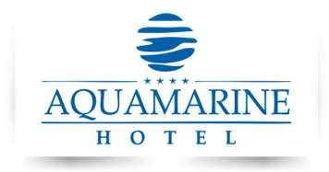

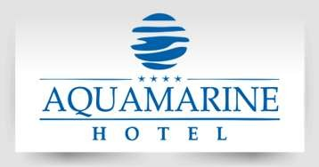
1

GENERAL DESCRIPTION

Aquamarine Hotel is the perfect choice for your All-inclusive family vacation. Just a 5 minute walk from the beach, and just a few bus stops from the ancient city of Nessebar. The hotel offers not just accommodation, but comfort and hospitality for an unforgettable vacation. It has a large pool for adults and a pool for children with water slides.

All-day quality animation for your children and for you - water gymnastics, water polo, volleyball, stretching, darts, aero hockey, bocce, dancing and many cocktail games. You can test your strength in sports’ tournaments on our sandy volleyball and mini football field. Parking is also available – 20 BGN per day.
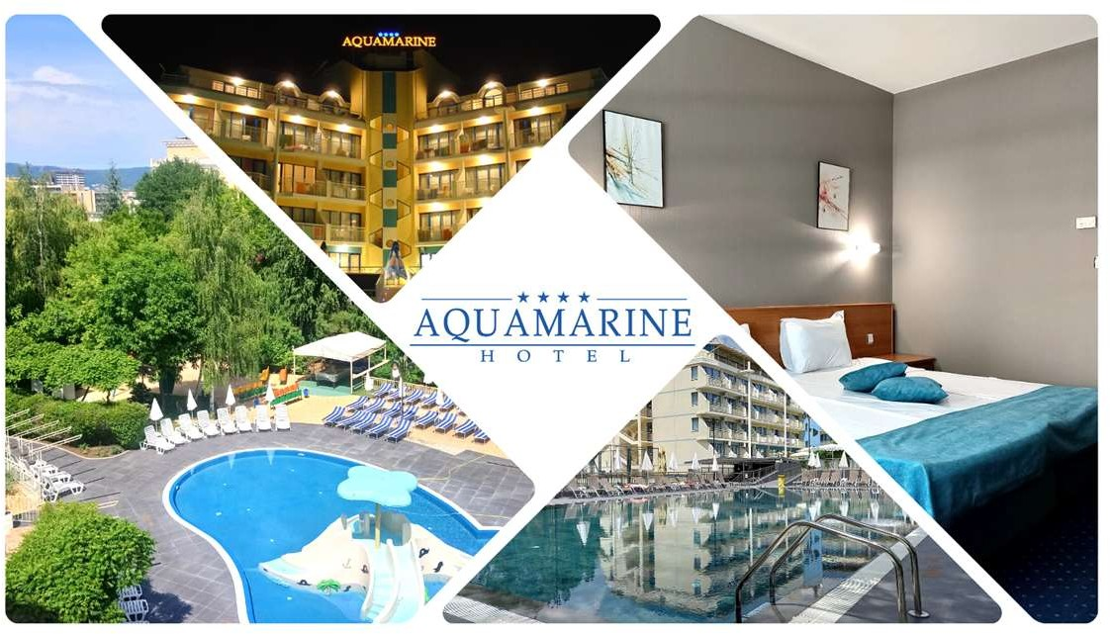

All rooms in Aquamarine Hotel have balcony, two standard twin beds, armchair/s, telephone, satellite TV, air conditioning, and mini fridge, bathroom with bathtub, shower and hairdryer. Most rooms have the possibility for 1 or 2 extra beds (extendable sofa bed type).

Check in is after 15:00 / Check out before 11:00

2

ALL-INCLUSIVE DESCRIPTION
Main Restaurant - Big variety of international dishes, specially adapted kids buffet and ice-cream corner are waiting for you in our main restaurant. Our chefs can’t wait to surprise you with our homemade bread, pizza and pastries. Dessert bar, soup bar, salad bar and hot meal buffet are designed to satisfy every taste.

07:30 - 10:00: Buffet breakfast with soft and hot drinks included.
12:00 - 14:00: Lunch buffet with hot and soft drinks included; Local beer and wine 18:30 - 21:00: Buffet dinner with hot and soft drinks included; Local beer and wine

Two themed evenings per week - Bulgarian and Mediterranean
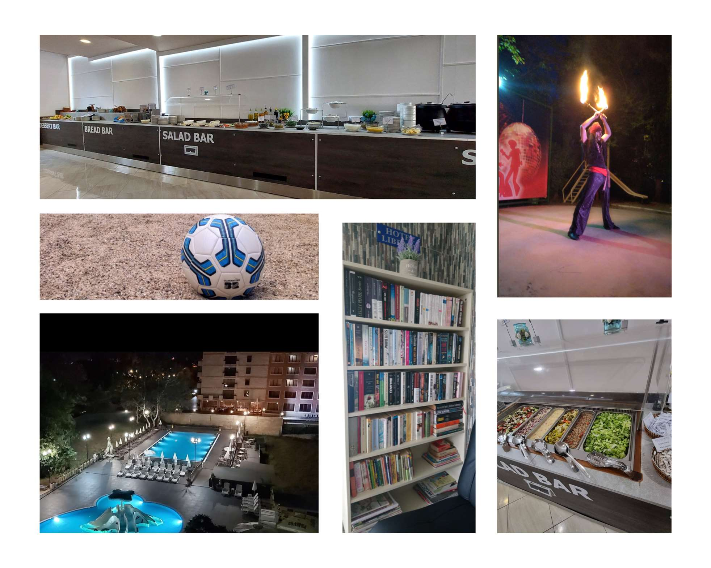

ALL-INCLUSIVE

“Mermaid Pool bar & Snacks” /opened from 20.06 to 09.09/

10:30 - 17:30: Variety of hot and cold snacks, pizza, burgers etc.
10:00 - 18:00: Variety of hot and soft drinks; alcoholic and non-alcoholic cocktails; Bulgarian spirits, local beer and wine.

“Arcade Lobby bar”

10:00 - 23:00: Big variety of hot and soft drinks; alcoholic and non-alcoholic cocktails; Bulgarian spirits, Local beer and wine

Free services:

Free high speed Wi-Fi internet in all the rooms and common areas
Baby cot, iron, ironing board, kettle in the room upon request.
Pool towels free, but against a deposit 20BGN per towel.
Free sand volleyball and football field. Pool lounge chairs, tables and umbrellas.
Free use of kid’s playground – swings and slides. Water gymnastics, pool volleyball, water polo, stretching, darts etc.
Daily multilingual entertainment activities and animation for children, mini disco - 6 days per week /from 20.06 to 09.09/

Rent-a-car
Aqua park tickets and shuttle
Massages
Paid services:

Parking space (upon availability) – 20BGN per day
3
Safety deposit box at the reception desk- BGN 5 per day, BGN 30 per week
Arcade games in the lobby bar - flipper, electronic game consoles, jaggy football etc. – 1-3 BGN PER GAME Open air Billiards and air hockey by the pool – with tokens – 1-3 BGN per game

* To use the ALL-INCLUSIVE services, guests are required to wear a special bracelet.
*All inclusive starts with snacks by the pool from 14:00 on the day of check-in and ends with lunch at 12:00 on the day of check-out.

4

